**Hiring Process Analytics** (Statistics project)**: -**

Name: Arpan Paul

GitHub Link: -

**Project Overview:** This project is focused on analysing the hiring process within the company to understand key factors that shape workforce dynamics. The primary objective is to gain insights into the gender distribution, salary trends, departmental composition, and position hierarchy within the organization. By examining these elements, the project seeks to reveal hiring patterns and organizational structures, offering insights that can guide future recruitment strategies and promote a balanced workplace.

**Methodology:** To achieve the project’s objectives, we adopted a systematic approach to data analytics. A dataset detailing recent hires, including attributes such as gender, salary, department, and position tier, was acquired. Microsoft Excel 2022 was selected as the core analysis tool due to its extensive data manipulation capabilities and ease of use for visualizing data insights. Through techniques such as pivot tables, data visualization charts, and Excel formulas, we analysed the dataset and extracted insights that paint a clear picture of hiring trends.

**Tools and Technologies:**

* Software Platform: Microsoft Excel 2019
* Rationale for Choice: Excel provides a comprehensive suite of data analysis tools, including pivot tables, charts, and statistical functions. These tools enabled us to conduct in-depth exploration and visualization of the hiring data, leading to a thorough understanding of the key patterns and trends.

**Key Findings and Insights:** Throughout the analysis, several meaningful insights were uncovered:

* Gender Distribution Analysis: By examining gender ratios within different departments and positions, we gained insights into diversity across roles. This breakdown offered a snapshot of gender representation and highlighted areas where gender diversity could be further enhanced.
* Salary Analysis: An in-depth look at salary structures across departments and position tiers revealed disparities and alignment trends. This analysis allowed us to identify potential areas for salary adjustments, ensuring that compensation aligns with industry standards and internal equity.
* Departmental Composition: The analysis of departmental distribution illustrated how different departments are structured within the hiring framework. It highlighted the relative sizes of departments, revealing which areas have seen the most growth and where additional resources might be allocated in future hiring plans.
* Position Tier Analysis: By categorizing hires into various position tiers, we identified trends in position hierarchies and growth paths within the company. This analysis provided valuable insights into the distribution of roles at entry, mid, and senior levels, which can help shape future workforce planning.

Each of these insights’ sheds light on different dimensions of the hiring process, helping us understand trends that impact organizational growth and balance. By identifying these patterns, we can support informed decision-making and foster a more inclusive and structured workplace.

**Conclusion:** The project has successfully highlighted key areas within the company’s hiring practices, revealing trends that offer valuable guidance for future recruitment strategies. The findings emphasize the importance of a balanced approach to hiring across gender, salary, and departmental structures. These insights will be instrumental in refining the company's approach to talent acquisition, fostering a workplace environment that is diverse, equitable, and growth-oriented.

**EDA: -**

Changing the date and time column: -

Step 1: Select the Date-Time Column

1. In Power Query, locate the column that contains your date-time values (e.g., Interview Taken On).
2. Click on this column to select it.

Step 2: Split the Date-Time Column

1. With the date-time column selected, go to the Home tab in Power Query.
2. Click Split Column > By Delimiter.
   * This opens the Split Column by Delimiter window.
3. In the Select or Enter Delimiter dropdown menu, choose Space.
   * This option will split the column where there’s a space between the date and time parts.
4. In the Split at section, ensure Each occurrence of the delimiter is selected.
5. Click OK.
   * Power Query will create two new columns, usually named Interview Taken On.1 and Interview Taken On.2, where the first column holds the date and the second column holds the time.

Step 3: Rename the New Columns

1. Double-click on the header Interview Taken On.1 and rename it to Interview Date.
2. Double-click on the header Interview Taken On.2 and rename it to Interview Time.

Step 4: Change Data Types

1. Change Interview Date to Date Type:
   * Select the Interview Date column.
   * Go to the Transform tab, find the Data Type dropdown on the left, and select Date.
2. Change Interview Time to Time Type:
   * Select the Interview Time column.
   * Go to the Transform tab, click on Data Type, and select Time.

**\*\*\* Change the headers names too:**



**Outliers Detection:**

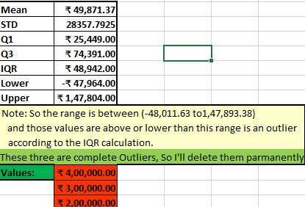

**Finding mode value of this dataset: -**

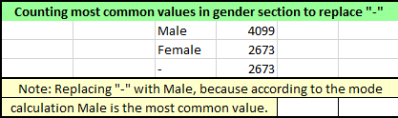

**A. Hiring Analysis:** The hiring process involves bringing new individuals into the organization for various roles.

**Your Task:** Determine the gender distribution of hires. How many males and females have been hired by the company?

**B. Salary Analysis:** The average salary is calculated by adding up the salaries of a group of employees and then dividing the total by the number of employees.

**Your Task:** What is the average salary offered by this company? Use Excel functions to calculate this.

**C. Salary Distribution:** Class intervals represent ranges of values, in this case, salary ranges. The class interval is the difference between the upper and lower limits of a class.

**Your Task:** Create class intervals for the salaries in the company. This will help you understand the salary distribution.

**D. Departmental Analysis:** Visualizing data through charts and plots is a crucial part of data analysis.

**Your Task:** Use a pie chart, bar graph, or any other suitable visualization to show the proportion of people working in different departments.

**E. Position Tier Analysis:** Different positions within a company often have different tiers or levels.

**Your Task:** Use a chart or graph to represent the different position tiers within the company. This will help you understand the distribution of positions across different tiers.